Lab 8: Indexing

- In a database, indexing is a technique used to optimize the retrieval of records from a table.

- Indexes are data structures that store a small portion of the table’s data, typically the values of one or more
columns, along with pointers to the corresponding rows in the table.

- These indexes are organized in a way that allows for efficient data searching, sorting, and retrieval.

Why do we use indexing in DBMS?

- Faster Data Retrieval: Indexes help speed up data retrieval operations, such as SELECT queries, by
providing a quick path to locate the desired rows in a table.

- Types of Indexes: There are different types of indexes, including:

  - Primary Index: This type of index is defined on an ordered data file, typically on a key field such as
the primary key of a relation.

  - Secondary Index: A secondary index may be generated from a candidate key field with a unique value
in every record or a non-key field with duplicate values.

  - Clustering Index: A clustering index is defined on an ordered data file, usually on a non-key field.

- Structure-Based Indexing

  - Dense Index: In a dense index, there is an index record for every search key value in the database. It
provides fast searching but requires more space to store index records.

  - Sparse Index: Sparse indexes do not have an index record for every search key. Instead, they contain search key values and pointers to the actual data. If the desired data is not directly found via the index, the system conducts a sequential search until it finds the data.

  - Multilevel Index: The index is stored alongside the actual database files on the disk. As the size of the database grows, the indices also increase. Multilevel indexing helps by breaking down the index into smaller indices, allowing the outermost level to be small enough to fit into memory.

  - B+ Tree: A B+ tree is a balanced search tree commonly used for indexing. It follows a multilevel index format where leaf nodes denote actual data pointers. B+ trees ensure balanced height and support both random and sequential access.

- Maintenance Overhead: While indexes can improve query performance, they also introduce overhead during data modification operations (INSERT, UPDATE, DELETE), as the indexes need to be updated to reflect changes in the underlying table.

- Index Selection: Deciding which columns to index requires consideration of the types of queries frequently executed against the table. Indexes should be created on columns frequently used in WHERE clauses, JOIN conditions, or ORDER BY clauses.

- Indexing Strategies: DBMSs employ various indexing strategies to organize and access data efficiently. Common strategies include B-tree, hash, and bitmap indexes, each with advantages and limitations.

- Monitoring and Optimization: Index usage and performance should be monitored regularly. Unused indexes may consume resources unnecessarily, and poorly designed indexes can degrade performance. Periodic index optimization, such as index rebuilding or reorganization, may be necessary to maintain optimal performance.

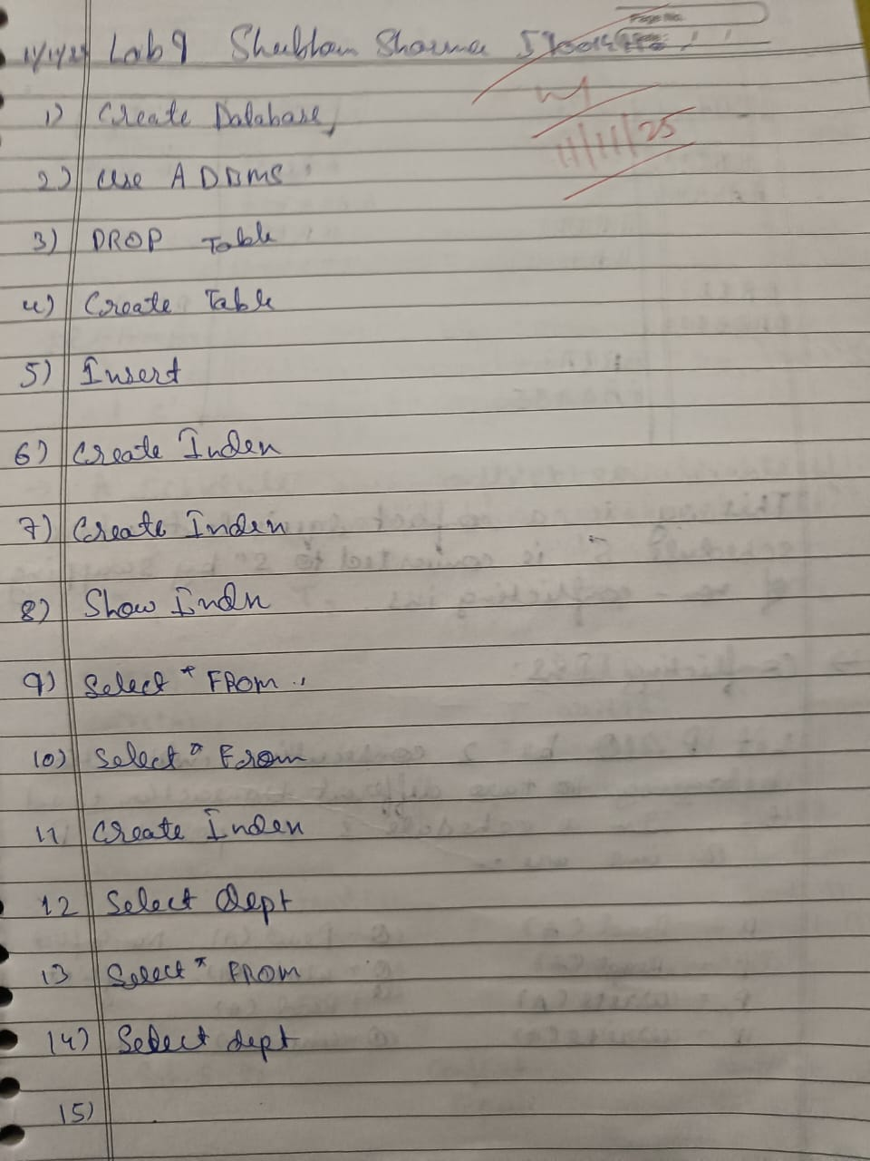

Lab Performance Question
1. Creating a Database and Table
CREATE DATABASE IF NOT EXISTS ADBMS_LAB;

use ADBMS_LAB;
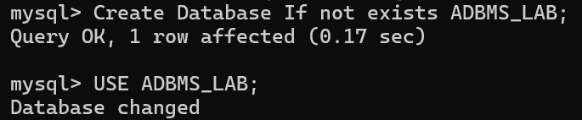
drop table employees;

CREATE TABLE employees (
id INT AUTO_INCREMENT PRIMARY KEY,
name VARCHAR(100), department VARCHAR(100),
salary DECIMAL(10, 2)
);
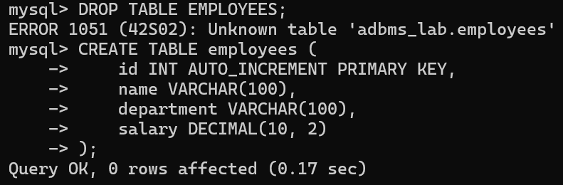

desc employees;
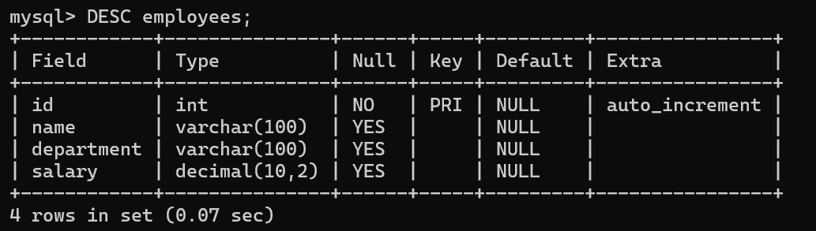
- This script creates a database named "ADBMS_LAB" if it doesn't exist.
- It then selects the newly created database.

• Finally, it creates a table named "employees" with columns for id, name, department, and salary.
2. Inserting Data into the Table
INSERT INTO employees (name, department, salary) VALUES
('John Doe', 'Engineering', 50000.00),
('Jane Smith', 'HR', 45000.00),
('Michael Johnson', 'Engineering', 55000.00),
('Emily Brown', 'Sales', 48000.00);
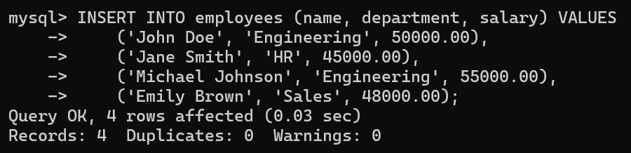
SELECT * FROM employees;
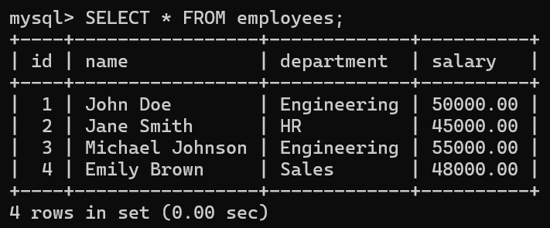
- Inserts data into the "employees" table, specifying values for name, department, and salary.
- Retrieves all rows from the "employees" table.
3. Creating Indexes
CREATE INDEX idx_department ON employees (department);
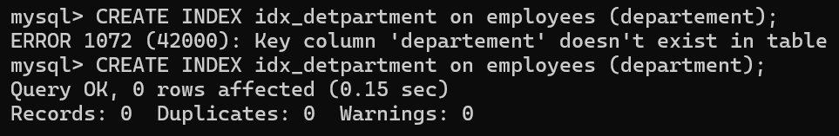
CREATE INDEX idx_salary ON employees (salary);
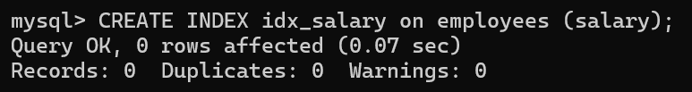
SHOW INDEX FROM employees;
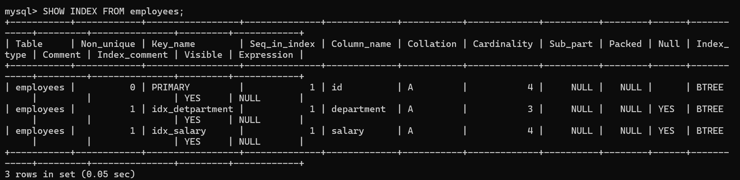
• Creates indexes on the "department" and "salary" columns of the "employees" table, which can improve query performance.
4. Querying with Conditions
SELECT * FROM employees WHERE department = 'Engineering';  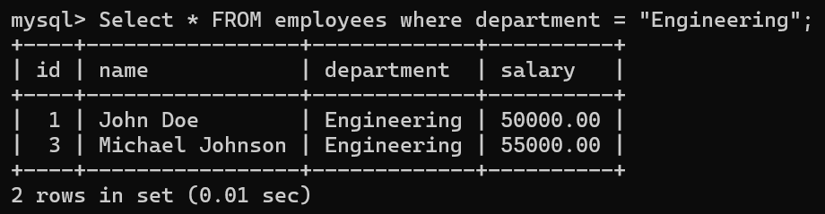 | 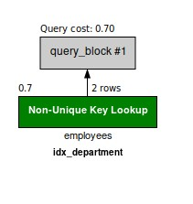

SELECT * FROM employees WHERE salary > 50000.00;  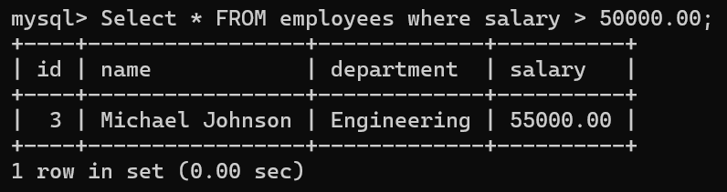 | 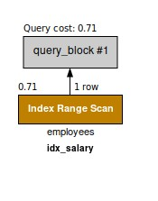
5. Creating Index
CREATE INDEX idx_covering ON employees (department, salary);  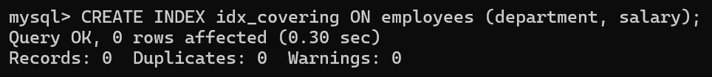  A covering index is an index that contains all the columns required by a query, allowing MySQL to retrieve the data directly from the index without accessing the actual table. This can improve query performance by avoiding the need to fetch data from the table.  SELECT department, salary FROM employees WHERE department = 'Engineering';  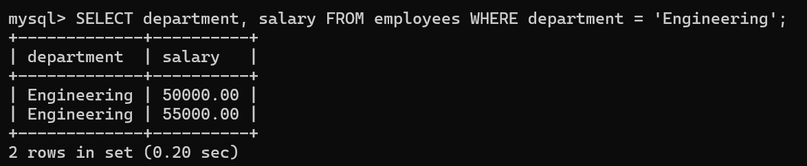 | 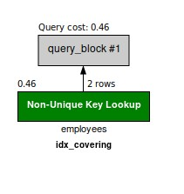

SELECT * FROM employees USE INDEX (idx_salary) WHERE salary > 50000.00;  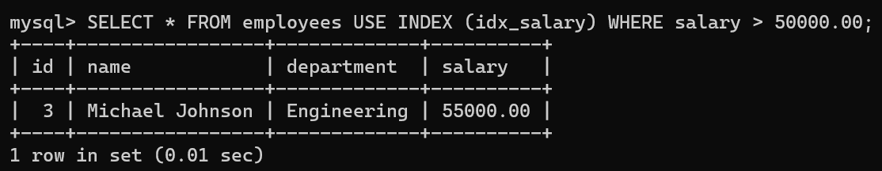  MySQL allows you to provide hints to the query optimizer to specify which index to use for a particular query. This can be useful when you want to ensure that a specific index is used, especially if the optimizer's choice is not optimal. | 
SELECT * FROM employees USE INDEX (idx_covering) WHERE salary > 50000.00;  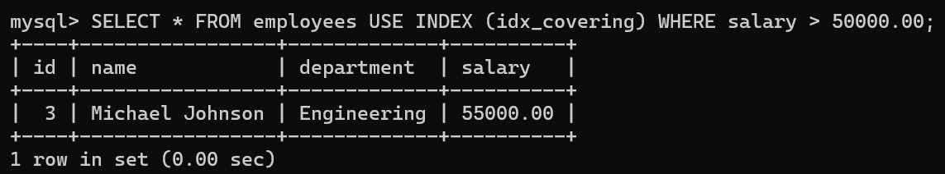 | 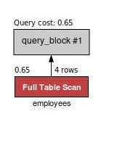

SELECT department, salary FROM employees USE INDEX (idx_covering) WHERE salary >  50000.00;  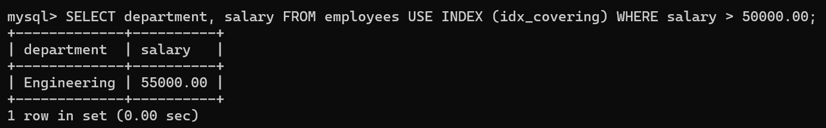 | 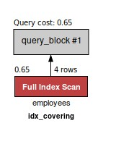
-- Query using index merge  SELECT * FROM employees WHERE department = 'Engineering' AND salary > 50000.00;  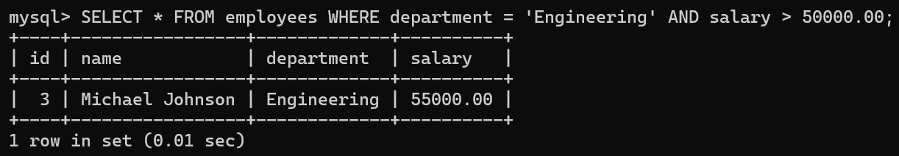  MySQL optimizer can sometimes use multiple indexes and merge their results to fulfill a query.  This can be advantageous when individual indexes are selective but together cover the query conditions effectively. | 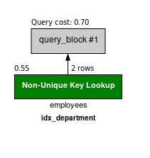

-- Query utilizing index condition pushdown  SELECT * FROM employees WHERE salary > 50000.00 AND department = 'Engineering';  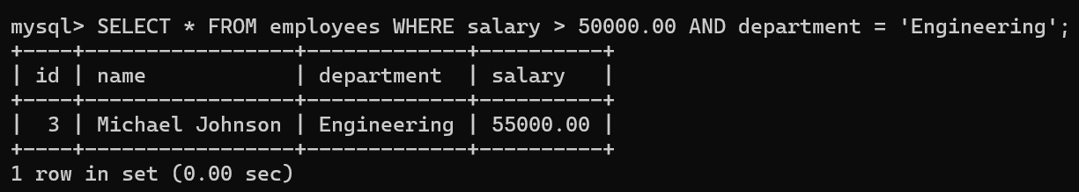  Index condition pushdown is a feature in MySQL that pushes filter conditions into the index scan, reducing the number of rows fetched from the table. | 
-- Query with forced index  SELECT * FROM employees FORCE INDEX (idx_department) WHERE department =  'Engineering';  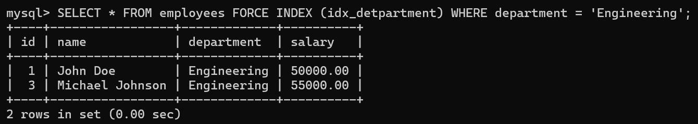  You can force MySQL to use a specific index for a query using the FORCE INDEX directive. This can be useful when you know that a particular index is optimal for a query. | 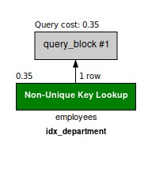

CREATE INDEX idx_descending ON employees (department DESC);  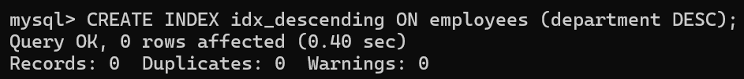  To create an index in descending order, you need to explicitly specify the order using the DESC keyword.  SELECT department, salary FROM employees USE INDEX (idx_descending) WHERE department = 'Engineering';  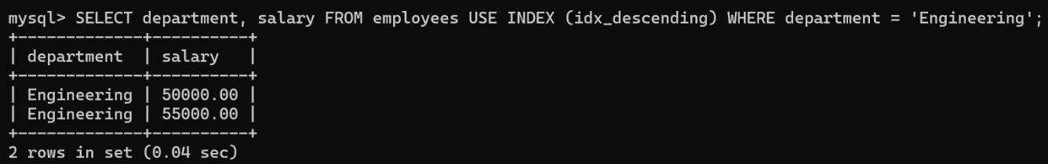 | 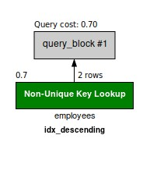
-- Query using an index for descending order scan  SELECT * FROM employees WHERE salary > 50000.00 ORDER BY department DESC;  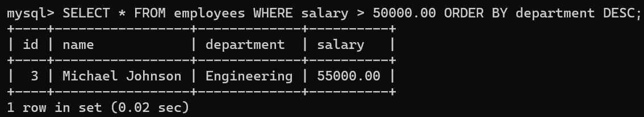  When querying data using an index, MySQL automatically utilizes the index for both ascending and descending order scans. However, it's essential to ensure that your query conditions match the index order for optimal performance. | 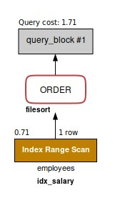
SELECT * FROM employees USE INDEX (idx_descending) WHERE salary > 50000.00 ORDER BY department DESC;  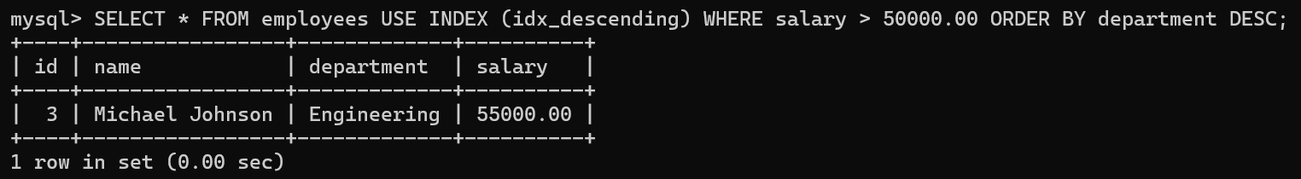 | 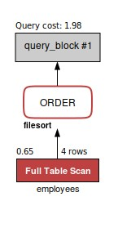
CREATE INDEX idx_mixed_order ON employees (department ASC, salary DESC);  You can also create an index with multiple columns, some in ascending order and others in descending order.  SELECT * FROM employees USE INDEX (idx_mixed_order) WHERE salary > 50000.00;  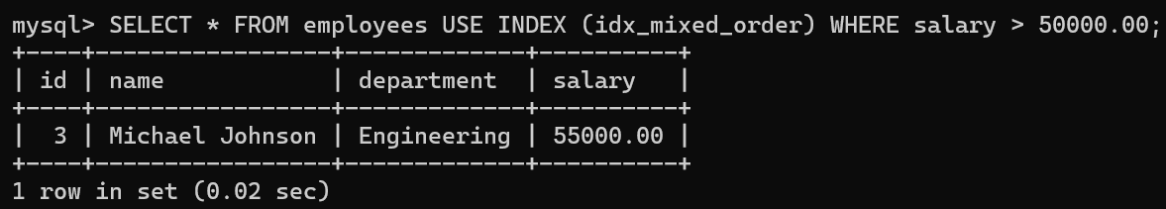 | 
SHOW INDEX FROM employees;
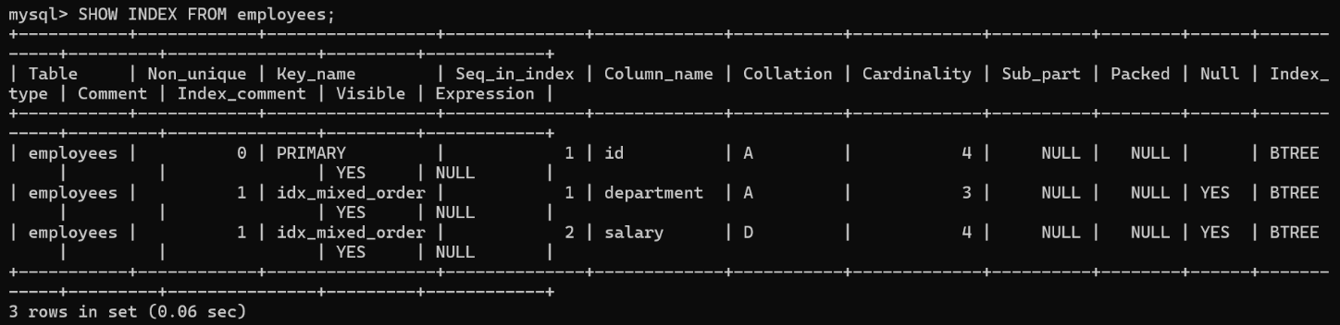

Table | Non_unique | Key_name | Seq_in_index | Column_name | Collation | Cardinality | Sub_part | Packed | Null | Index_type | Comment | Index_comment | Visible | Expression
employees | 0 | PRIMARY | 1 | id | A | 4 | NULL | NULL |  | BTREE |  |  | YES | NULL
employees | 1 | idx_department | 1 | department | A | 3 | NULL | NULL | YES | BTREE |  |  | YES | NULL
employees | 1 | idx_salary | 1 | salary | A | 4 | NULL | NULL | YES | BTREE |  |  | YES | NULL
employees | 1 | idx_covering | 1 | department | A | 3 | NULL | NULL | YES | BTREE |  |  | YES | NULL
employees | 1 | idx_covering | 2 | salary | A | 4 | NULL | NULL | YES | BTREE |  |  | YES | NULL
employees | 1 | idx_descending | 1 | department | D | 3 | NULL | NULL | YES | BTREE |  |  | YES | NULL
employees | 1 | idx_mixed_order | 1 | department | A | 3 | NULL | NULL | YES | BTREE |  |  | YES | NULL
employees | 1 | idx_mixed_order | 2 | salary | D | 4 | NULL | NULL | YES | BTREE |  |  | YES | NULL

6. Drop Index
DROP INDEX idx_department ON employees;
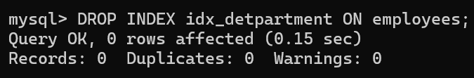
DROP INDEX idx_salary ON employees;
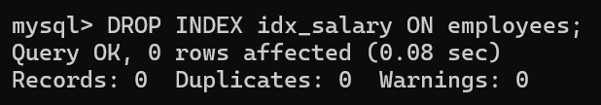
DROP INDEX idx_covering ON employees;
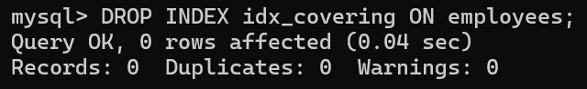
DROP INDEX idx_covering ON employees;
DROP INDEX idx_descending ON employees;
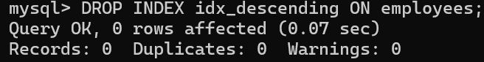
DROP INDEX idx_mixed_order ON employees;
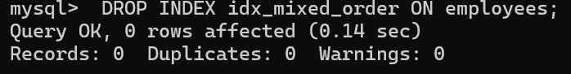
SHOW INDEX FROM employees;
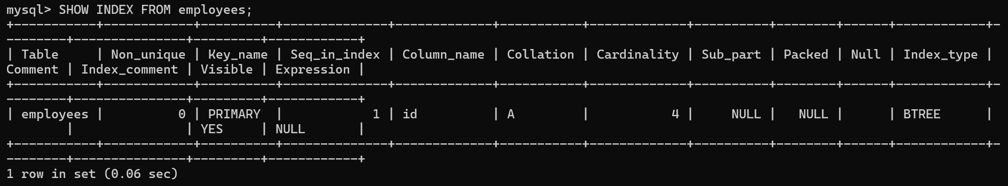

Run every query and make the report of every Image of Indexing
7. Create the table
CREATE TABLE books (
book_id INT AUTO_INCREMENT PRIMARY KEY, title VARCHAR(255), author VARCHAR(255),
publication_year INT
);
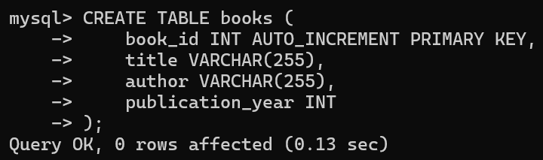
8. Insert The Data
INSERT INTO books (title, author, publication_year) VALUES
('The Adventures of Tom Sawyer', 'Mark Twain', 1876),
('The Picture of Dorian Gray', 'Oscar Wilde', 1890),
('Alice\'s Adventures in Wonderland', 'Lewis Carroll', 1865),
('The War of the Worlds', 'H.G. Wells', 1898),
('Dracula', 'Bram Stoker', 1897),
('Jane Eyre', 'Charlotte Brontë', 1847),

('Wuthering Heights', 'Emily Brontë', 1847),
('Frankenstein', 'Mary Shelley', 1818),
('The Count of Monte Cristo', 'Alexandre Dumas', 1844),
('The Adventures of Sherlock Holmes', 'Arthur Conan Doyle', 1892),
('The Strange Case of Dr. Jekyll and Mr. Hyde', 'Robert Louis Stevenson', 1886),
('The Hound of the Baskervilles', 'Arthur Conan Doyle', 1902),
('Les Misérables', 'Victor Hugo', 1862),
('Anna Karenina', 'Leo Tolstoy', 1877),
('War and Peace', 'Leo Tolstoy', 1869),
('Crime and Punishment', 'Fyodor Dostoevsky', 1866),
('Gone with the Wind', 'Margaret Mitchell', 1936),
('The Grapes of Wrath', 'John Steinbeck', 1939),
('The Old Man and the Sea', 'Ernest Hemingway', 1952),
('The Sun Also Rises', 'Ernest Hemingway', 1926),
('Of Mice and Men', 'John Steinbeck', 1937),
('One Hundred Years of Solitude', 'Gabriel García Márquez', 1967),
('Don Quixote', 'Miguel de Cervantes', 1605),
('The Scarlet Letter', 'Nathaniel Hawthorne', 1850), ('The Canterbury Tales', 'Geoffrey Chaucer', 1400),
('Heart of Darkness', 'Joseph Conrad', 1899),
('The Odyssey', 'Homer', 800),
('The Iliad', 'Homer', 800),
('Catch-22', 'Joseph Heller', 1961),
('To the Lighthouse', 'Virginia Woolf', 1927),
('Slaughterhouse-Five', 'Kurt Vonnegut', 1969),
('The Bell Jar', 'Sylvia Plath', 1963),
('The Great Expectations', 'Charles Dickens', 1861),
('The Adventures of Huckleberry Finn', 'Mark Twain', 1884),
('The Chronicles of Narnia', 'C.S. Lewis', 1950),
('Lord of the Flies', 'William Golding', 1954),
('The Outsiders', 'S.E. Hinton', 1967),
('The Road', 'Cormac McCarthy', 2006),
('Beloved', 'Toni Morrison', 1987),
('Pride and Prejudice', 'Jane Austen', 1813),
('The Hobbit', 'J.R.R. Tolkien', 1937),
('The Lord of the Rings', 'J.R.R. Tolkien', 1954),
('Harry Potter and the Philosopher\'s Stone', 'J.K. Rowling', 1997),
('Moby-Dick', 'Herman Melville', 1851),
('Brave New World', 'Aldous Huxley', 1932),
('The Da Vinci Code', 'Dan Brown', 2003),
('Angels & Demons', 'Dan Brown', 2000),
('The Girl with the Dragon Tattoo', 'Stieg Larsson', 2005),
('The Hunger Games', 'Suzanne Collins', 2008),
('The Catcher in the Rye', 'J.D. Salinger', 1951),
('The Martian', 'Andy Weir', 2011),
('A Game of Thrones', 'George R.R. Martin', 1996),
('The Help', 'Kathryn Stockett', 2009),
('The Girl on the Train', 'Paula Hawkins', 2015),
('Gone Girl', 'Gillian Flynn', 2012),
('The Lovely Bones', 'Alice Sebold', 2002),
('Life of Pi', 'Yann Martel', 2001),
('The Alchemist', 'Paulo Coelho', 1988),
('Twilight', 'Stephenie Meyer', 2005),
('The Secret Life of Bees', 'Sue Monk Kidd', 2001),
('The Book Thief', 'Markus Zusak', 2005),
('Water for Elephants', 'Sara Gruen', 2006),
('The Girl with the Pearl Earring', 'Tracy Chevalier', 1999),
('The Help', 'Kathryn Stockett', 2009),
('The Kite Runner', 'Khaled Hosseini', 2003),
('The Glass Castle', 'Jeannette Walls', 2005),
('Eat, Pray, Love', 'Elizabeth Gilbert', 2006),
('The Time Traveler\'s Wife', 'Audrey Niffenegger', 2003),
('The Goldfinch', 'Donna Tartt', 2013),
('Big Little Lies', 'Liane Moriarty', 2014),
('The Nightingale', 'Kristin Hannah', 2015),
('The Underground Railroad', 'Colson Whitehead', 2016),
('The Silent Patient', 'Alex Michaelides', 2019),
('Where the Crawdads Sing', 'Delia Owens', 2018),
('Becoming', 'Michelle Obama', 2018),
('Educated', 'Tara Westover', 2018),
('Circe', 'Madeline Miller', 2018),
('Normal People', 'Sally Rooney', 2018),
('Little Fires Everywhere', 'Celeste Ng', 2017),
('The Testaments', 'Margaret Atwood', 2019),
('The Tattooist of Auschwitz', 'Heather Morris', 2018),
('The Wife Between Us', 'Greer Hendricks', 2018),
('The Silent Patient', 'Alex Michaelides', 2019),
('Where the Crawdads Sing', 'Delia Owens', 2018),
